**VII Insider is brought to you by The VII Foundation in partnership with PhotoWings and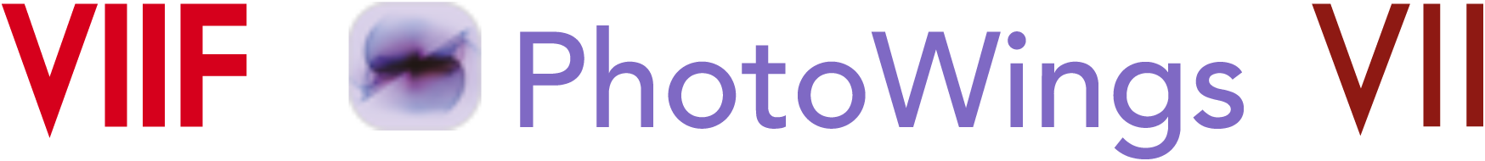 VII Photo Agency.**

We are excited to announce that **[PhotoWings](http://photowings.org/)** — a US-based non-profit dedicated to utilizing the power of photography to further deep thinking, communication, and action — is partnering with the VII Foundation to support and enhance our VII Insider programs.

PhotoWings' mission is to highlight and help facilitate the power of photography to influence the world, to help photography to be better understood, created, utilized, seen, and saved. Their support allows us to remove the financial barriers to full membership and make VII Insider available to everyone at no cost. Moving forward, VII Insider event recordings will be accessible on both the [VII Insider platform](https://viiphoto.com/recordings-resources/) and PhotoWings' expansive [media archive](http://photowings.org/videos/).

Thank you again for your support of VII Insider; we are thrilled at the response to the programming so far and look forward to developing new ideas to share with you. We will be in contact through our newsletter and hope to see you online at some of the exciting programs coming in the next few months.

If you have any questions — or ideas on what you might like to see on the platform — please be in touch with us at **[insider@viiphoto.com](mailto:insider@viiphoto.com)**.

**Join Us for A Special Event on March 30!**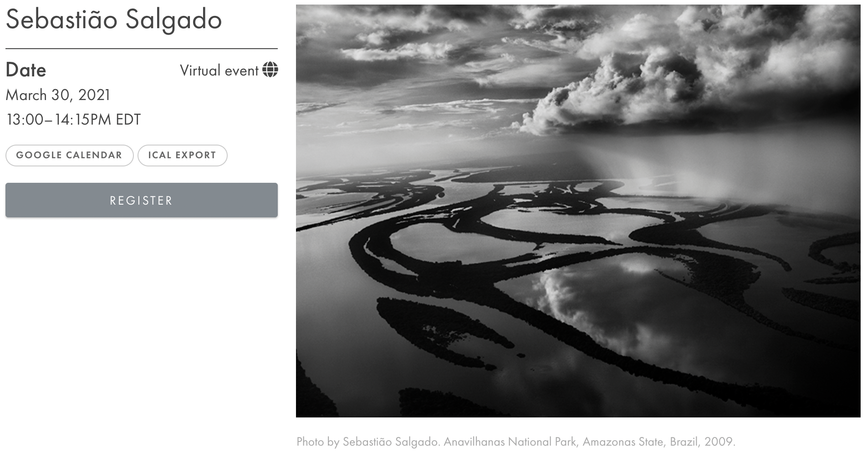

Internationally-renowned photographer Sebastião Salgado has spent years documenting the vast lungs of the Earth that stretch through his native country of Brazil and neighboring nations. “Amazônia” is his ongoing comprehensive survey of isolated indigenous communities, wildlife, and the aerial landscapes of the untouched regions of the Amazon. In conversation with VII Photo Agency Mentor Program photographer **[Leonardo Carrato](https://viiphoto.com/profile/leonardo-carrato/)**, Salgado will talk about the challenges involved in multi-national and global long-term projects, and the importance of photography as a powerful tool for change, citing real-world examples where it has made a difference.

Why did Salgado choose to dedicate his career entirely to covering major social issues around the world? What philosophical and moral dilemmas have led him down this path?

This event with Sebastião Salgado kicks off a series that, led by Carrato, will invite guests from within Brazil’s vibrant photography community to discuss the country’s extensive visual ethnography.

**The conversation will be held in Portuguese and interpreted live into English.**[Click here](https://viiphoto.com/vii-event/sebastiao-salgado/)**to RSVP.**

To attend this FREE VII Insider event, simply register for a **[FREE account here](https://viiphoto.com/become-a-vii-insider/)**. Once you’ve logged in, you’ll see a link to register via Zoom on this event page. After registration, you’ll receive a link from Zoom with the webinar details. If you have any questions, contact **[insider@viiphoto.com](mailto:insider@viiphoto.com)**.

**About The VII Foundation**

[The VII Foundation](https://theviifoundation.org/) is an independent, charitable media and education non-profit organization. It was founded by Ron Haviv and Gary Knight in 2001 when they recognized that media funding for long term projects was diminishing. In order to continue to produce work that addressed complex social, economic and human rights issues they started the Foundation as an independent non-profit structure to secure support for continuing documentary practice and education.

**About VII Photo Agency**

[VII](https://viiphoto.com/) is a storied photo agency founded a few days before 9/11 to challenge the convergence in the photography business when the trend for giant companies swallowing smaller independent agencies started. VII went small and photographer-owned, believing in the power and energy of collective effort when everyone else seemed to be going big and corporate. VII remains a disruptive and innovative business unafraid to swim against the prevailing currents.

**About PhotoWings**

[PhotoWings'](http://photowings.org/) mission is to highlight and help facilitate the power of photography to influence the world. We help photography to be better understood, created, utilized, seen, and saved.